**Material & Methods**

Single cell dataset

Dataset raw count table and published metadata was downloaded from GSE63472 accession code. A modified seurat pipeline was used to re-analyze these single-cell RNAseq. First, genes that was not expressed in at least 10 cells were excluded from our analysis. After that, only cells with 500 to 5000 genes and less than 5% of mitochondrial genes expression were selected (n = 21494 cells). Metadata variables as number of genes and percentage of mitochondrial expression were also used to regress out some unnecessary clustering bias. Based on *PCElbowPlot*, we used 30 PC’s in *FindClusters* (resolution = 2) and *RunTSNE* seurat’s functions. After that, using old assigned clusters and markers found by *FindAllMarkers* function, a new assigned clusters were labeled. Since our aim was analyze retinal cell groups, only amacrine, astrocytes, bipolar, cones, ganglion, horizontal, muller glia and rod cells were used (n = 21176). Cones and rod cells were merged in a single-group (Photoreceptors).

**Results**

To better understand expression of some markers in retina cell groups, we used a published dataset by macosko and collaborators. Based on new clustering analysis and previous assignment, we establish new assigned clusters (Supplementary figure 1). In each group it was found differentially expressed genes, for example, Amacrine (*Rlbp1, Glul*), Astrocytes (*Gfap*), Photoreceptors (*Nrl, Rho, Rcvrn, Pde6g*), Horizontal (*Prox1, Lhx1*), Bipolar (*Vsx2*), Amacrine (*Pax6, Slc32a1, Gad1, Gad2*) and RGCs (*Slc17a6, Calb2, Pou4f1, Syn1, Rbfox3, Tubb3, Pvalb*) (Figure 1 and Table 1). *Chat* and *Th* had not a significant expression in any of our assigned groups (Figure 1).

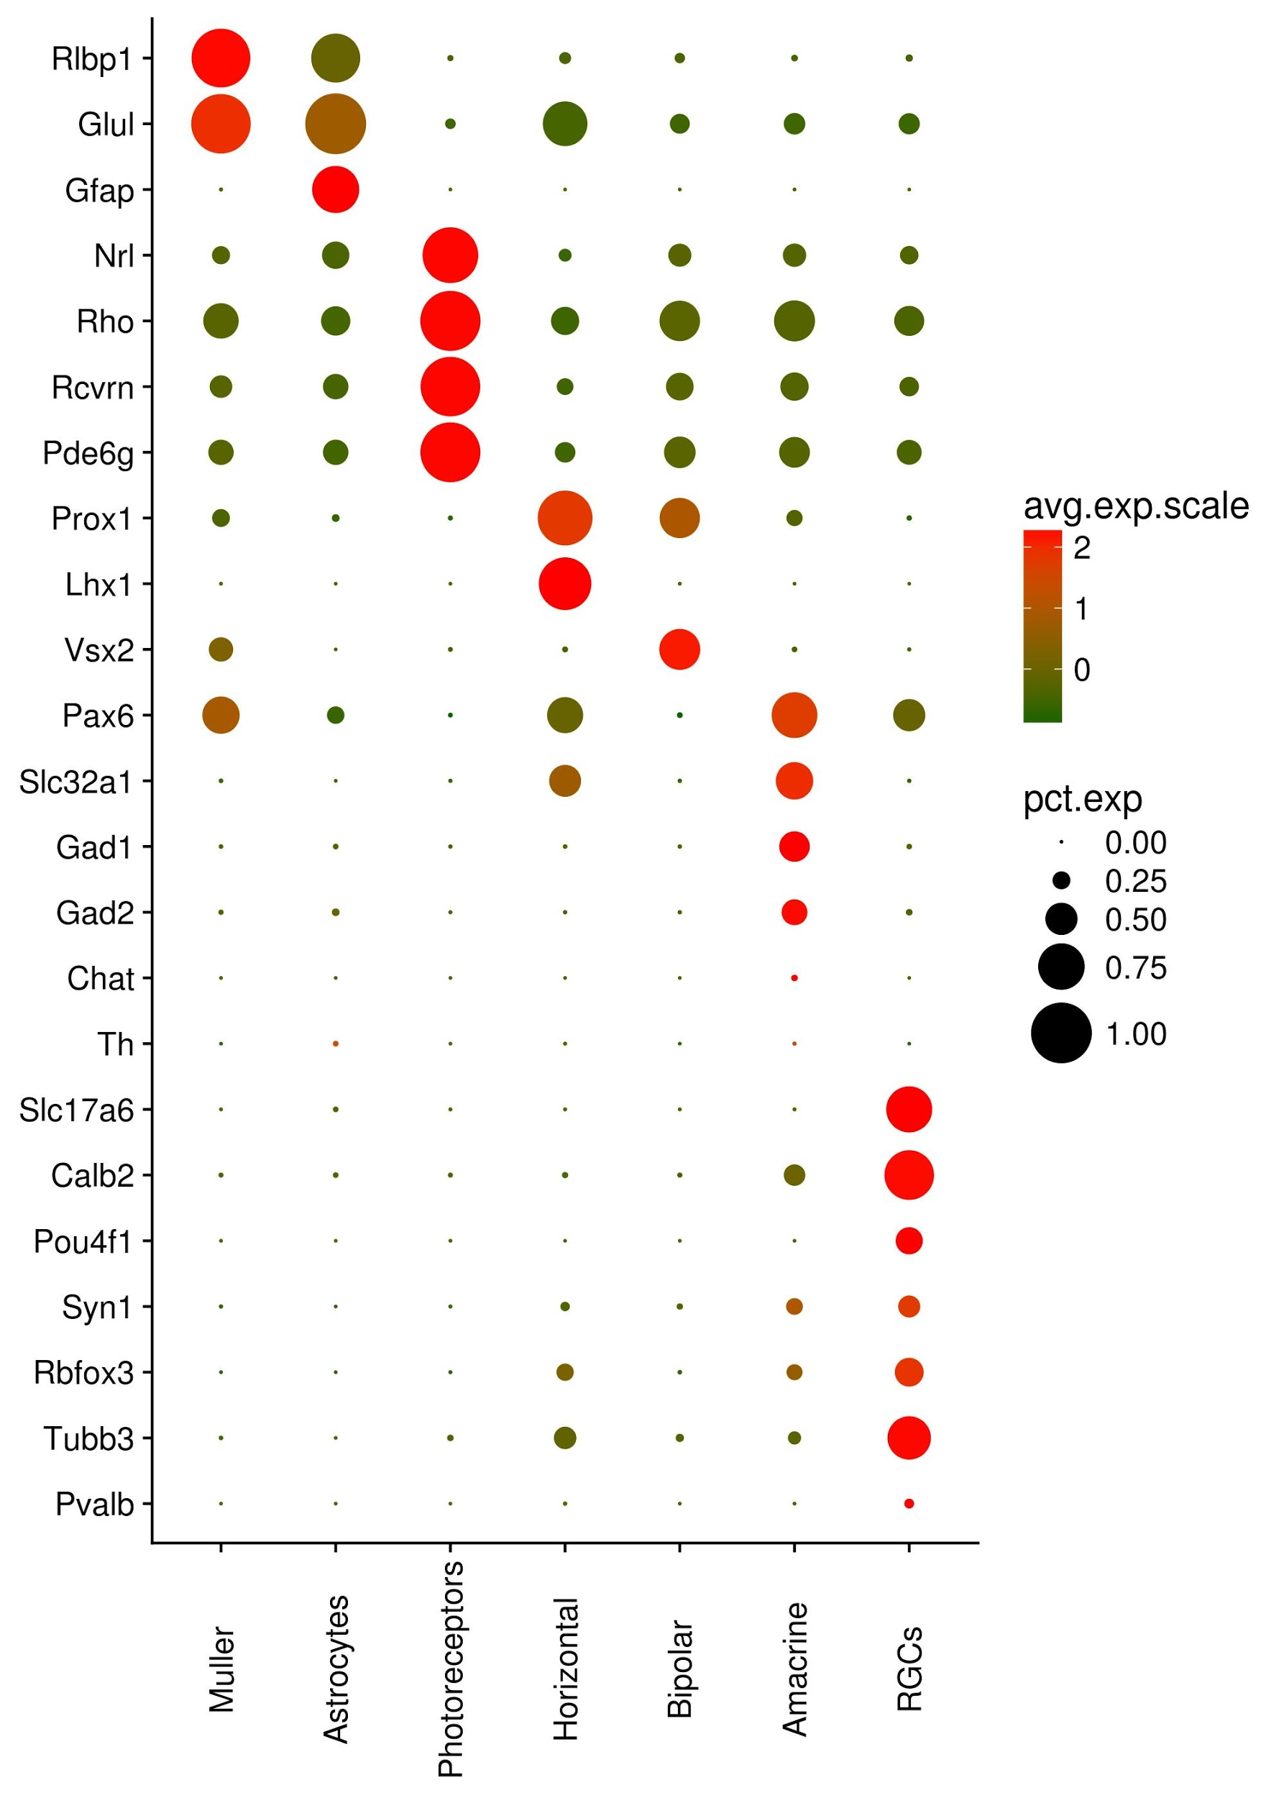

**Fig 1. Retinal cell markers among new assigned groups.** Selected genes viewed in assigned cell groups. Percentage of cells and average scaled expression can be interpreted as dot-size and color gradient (green to red), respectively.

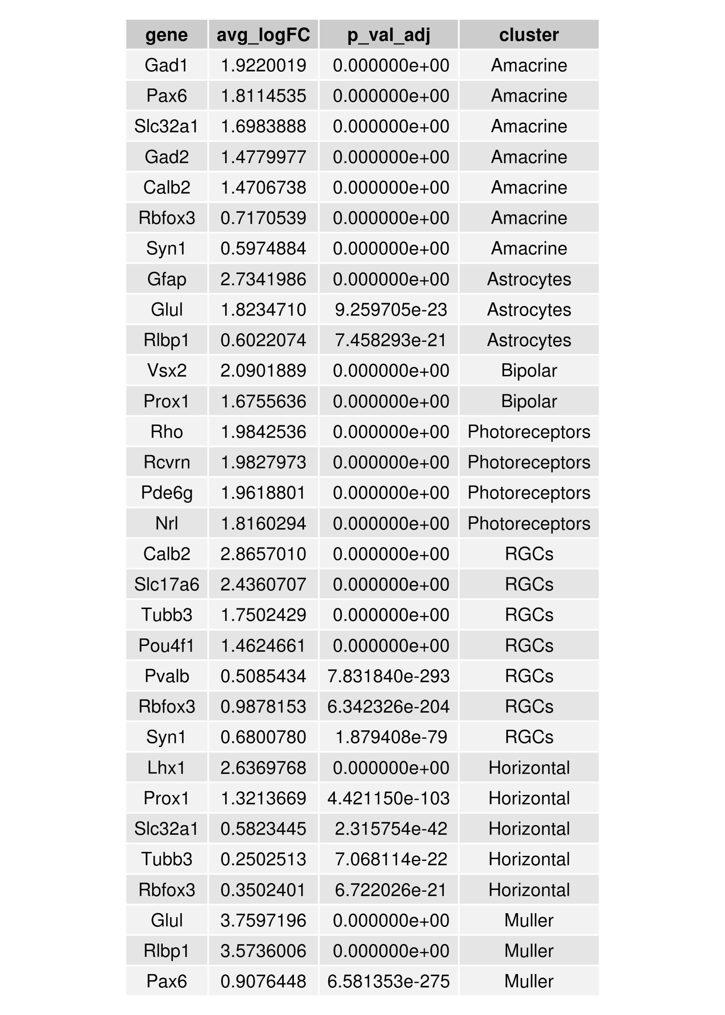

**Table 1. Selection of differentially expressed genes in new assigned groups.** Table shows in which clusters selected genes are differentially expressed. A p-adjusted value (p_val_adj) < 0.05 and average 10-log fold-change (avg_logFC) > 0.3 were used.

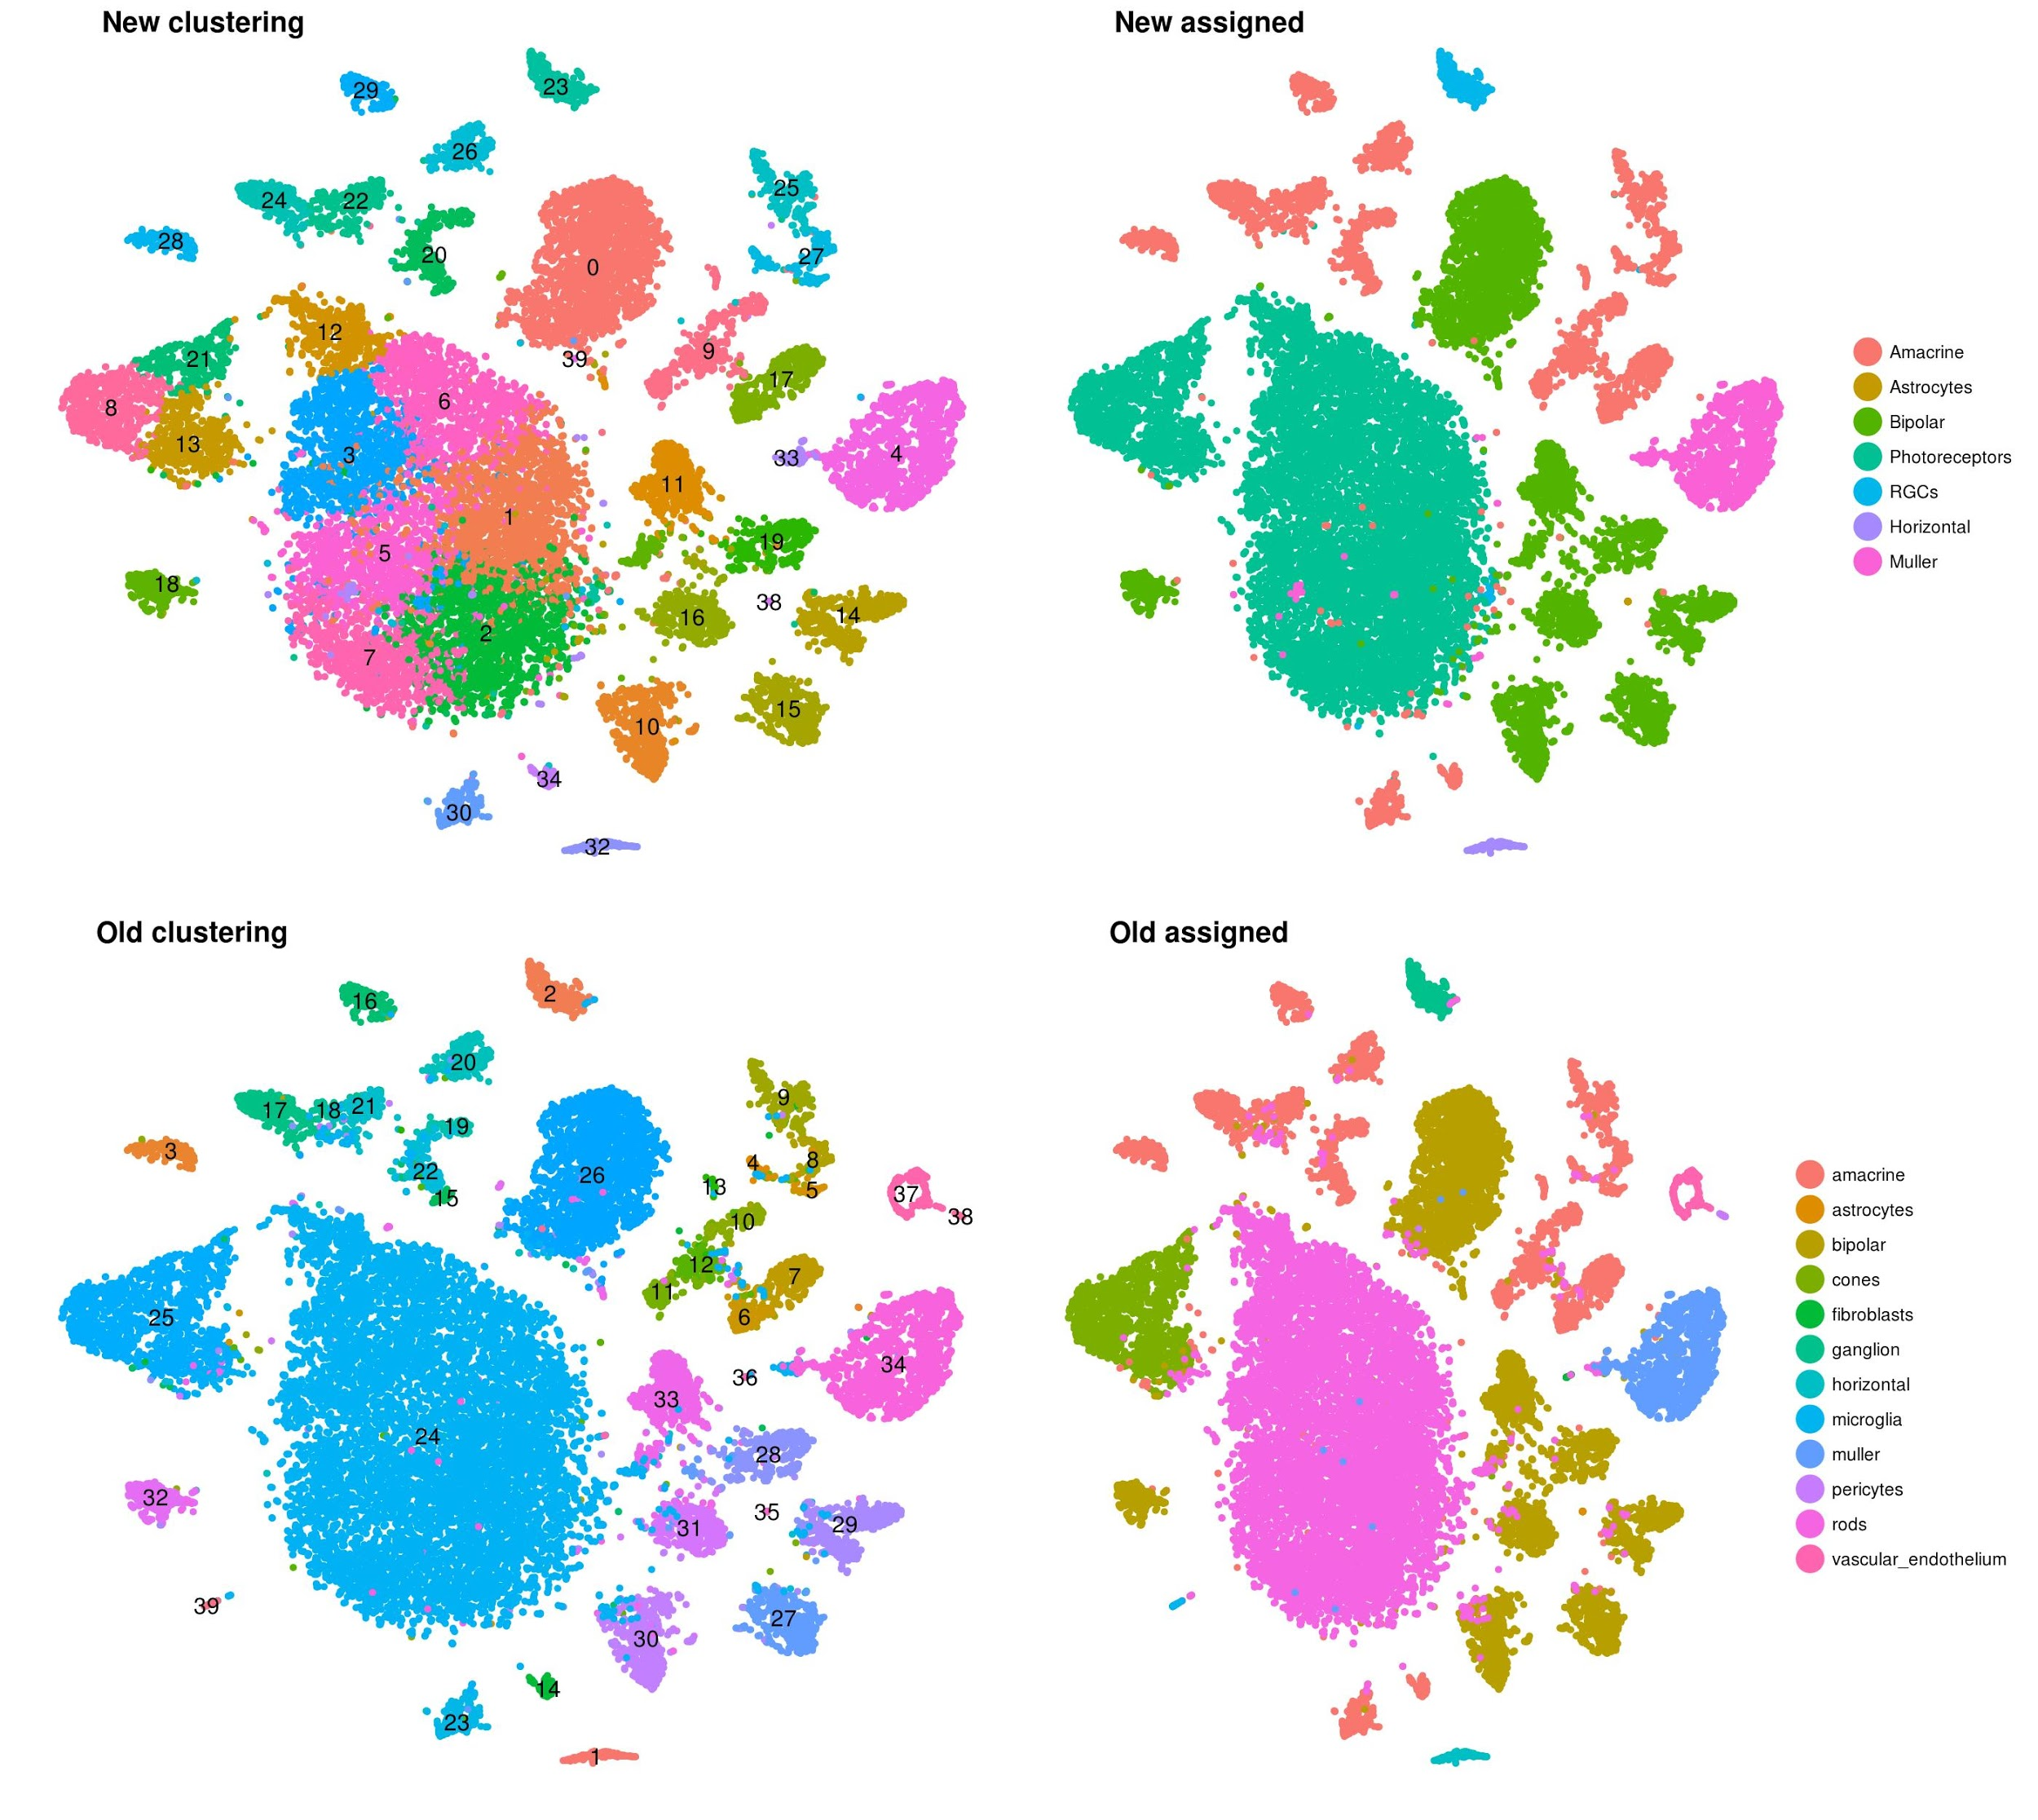

**Supplementary Fig. 1 - Old and new clusters and assigned clusters in tSNE plot view.** Previously it was found 39 clusters and 12 assigned groups (bottom). Now it has 39 clusters and 7 assigned groups (vascular endothelium, fibroblasts and pericytes were not included).